CUSTOMER SHOPPING BEHAVIOUR ANALYSIS
End-to-End Data Analytics Project Report
Python • SQL • Power BI

Prepared by: Aditya
Repository: github.com/theaditya24/customer-trends-data-analysis-SQL-Python-PowerBI
July 2026

Executive Summary
A leading retail company wanted to understand how demographics, product categories, discounts, and sales channels shape its customers' shopping behavior, with the goal of improving sales, satisfaction, and long-term loyalty. This project analyzes a 3,900-customer transaction dataset end-to-end — cleaning and engineering the data in Python, structuring and querying it in SQL to surface segment, loyalty, and purchase-driver insights, and visualizing the results in an interactive Power BI dashboard.
The business generated $233,081 in total revenue across 3,900 transactions, at an average basket of $59.76 and an average customer satisfaction score of 3.75 out of 5. The single clearest finding of the analysis is that per-customer spending and satisfaction are remarkably consistent across age, gender, subscription status, and payment method — revenue differences between segments are driven almost entirely by how many customers sit in each segment, not by how much any individual customer spends. Clothing and Accessories together account for 76% of revenue, and a large loyal core (39.7% of customers with 30+ prior purchases) anchors repeat business. Full findings and recommendations are detailed in Sections 5 and 6.

1. Business Problem Statement
Management had observed shifts in purchasing patterns across demographics, product categories, and sales channels, and wanted to know which factors — discounts, reviews, seasonality, or payment preferences — actually drive consumer decisions and repeat purchases. This translates into one overarching business question:
“How can the company leverage consumer shopping data to identify trends, improve customer engagement, and optimize marketing and product strategies?”
The project was scoped around five deliverables:
- Data Preparation & Modeling (Python): clean and transform the raw dataset for analysis.
- Data Analysis (SQL): structure the data and run queries to extract insights on customer segments, loyalty, and purchase drivers.
- Visualization & Insights (Power BI): build an interactive dashboard highlighting key patterns and trends.
- Report & Presentation: summarize findings and business recommendations for stakeholders (this document).
- GitHub Repository: house all Python scripts, SQL logic, and dashboard files in a well-structured repo.

2. Data Preparation (Python)
The raw dataset contains 3,900 customer transactions across 18 fields, covering demographics (age, gender, location), product details (category, item, size, color, season), transaction details (purchase amount, discount/promo usage, payment method, shipping type), and engagement signals (review rating, subscription status, previous purchases, purchase frequency).

2.1 Cleaning Steps
Step | Action Taken | Rationale
Missing values | 37 missing Review Rating values imputed with the category-level median | Median is resistant to outliers and preserves the rating distribution better than a global mean
Column names | Standardized to lower_snake_case (e.g. “Purchase Amount (USD)” → purchase_amount) | Removes spaces/special characters for reliable, readable access in code and SQL
Redundant column | Dropped promo_code_used after confirming it was identical to discount_applied in every row | Avoids duplicate signal / multicollinearity in downstream analysis

2.2 Feature Engineering
New Feature | Logic | Purpose
age_group | Binned age into Young Adult (≤25), Adult (26–40), Middle-Aged (41–60), Senior (61+) | Enables demographic segmentation and matches the Power BI dashboard's age-group visuals
purchase_frequency_days | Mapped text frequency (e.g. “Weekly”, “Monthly”) to a numeric day interval | Converts a categorical cadence into a numeric field usable for loyalty/recency-style analysis
After cleaning, the working dataset has 3,900 rows and 19 columns and was loaded into a SQL database (customers table) for structured querying.

3. Data Analysis (SQL) — Segments, Loyalty & Purchase Drivers
The cleaned data was loaded into a relational database and queried to answer the three questions called for in the business brief: who are the customer segments, what does loyalty look like, and what drives purchase behavior. Representative queries and their output are shown below; the full query set is included in the project repository.

3.1 Customer Segments by Age Group
SELECT age_group, COUNT(*) AS customers,
ROUND(AVG(purchase_amount),2) AS avg_purchase_usd,
ROUND(AVG(review_rating),2) AS avg_review_rating,
ROUND(AVG(previous_purchases),1) AS avg_previous_purchases
FROM customers
GROUP BY age_group
ORDER BY avg_purchase_usd DESC;
Age Group | Customers | Avg. Purchase | Avg. Rating | Avg. Prior Purchases
Young Adult | 571 | $60.65 | 3.82 | 24.6
Senior | 723 | $59.70 | 3.76 | 26.1
Adult | 1,103 | $59.69 | 3.75 | 25.0
Middle-Aged | 1,503 | $59.51 | 3.72 | 25.5
Table 1. Basket size and satisfaction are flat across age cohorts (within a $1.14 band); Middle-Aged is the largest cohort by headcount.

3.2 Loyalty Signals: Subscription & Discount Usage
SELECT subscription_status, COUNT(*) AS customers,
ROUND(AVG(previous_purchases),2) AS avg_previous_purchases,
ROUND(AVG(purchase_amount),2) AS avg_purchase_amount
FROM customers GROUP BY subscription_status;
Segment | Customers | Avg. Prior Purchases | Avg. Purchase | Avg. Rating
Subscribed — Yes | 1,053 | 26.08 | $59.49 | 3.75
Subscribed — No | 2,847 | 25.08 | $59.87 | 3.75
Discount Applied — Yes | 1,677 | 25.74 | $59.28 | —
Discount Applied — No | 2,223 | 25.06 | $60.13 | —
Table 2. Subscribers and discount users show slightly deeper purchase history than non-users, but not a materially larger basket.

3.3 Purchase Drivers: Category, Season & Fulfillment
Category | Transactions | Total Revenue | Avg. Purchase | % of Revenue
Clothing | 1,737 | $104,264 | $60.03 | 44.7%
Accessories | 1,240 | $74,200 | $59.84 | 31.8%
Footwear | 599 | $36,093 | $60.26 | 15.5%
Outerwear | 324 | $18,524 | $57.17 | 7.9%
Table 3. Clothing and Accessories together drive 76.5% of total revenue.
Season | Transactions | Revenue | Avg. Rating
Fall | 975 | $60,018 | 3.73
Spring | 999 | $58,679 | 3.79
Winter | 971 | $58,607 | 3.75
Summer | 955 | $55,777 | 3.73
Table 4. Demand is fairly evenly spread across seasons — a ~7% gap between the strongest (Fall) and weakest (Summer) quarter.
Shipping Type | Customers | Avg. Rating | Avg. Prior Purchases
Standard | 654 | 3.82 | 26.23
Express | 646 | 3.77 | 25.50
2-Day Shipping | 627 | 3.77 | 26.11
Next Day Air | 648 | 3.72 | 24.77
Free Shipping | 675 | 3.72 | 24.74
Store Pickup | 650 | 3.71 | 24.80
Table 5. Standard and 2-Day shipping post the highest satisfaction and repeat-purchase depth; Store Pickup is the weakest fulfillment path.

3.4 High-Frequency Loyal Segment
SELECT COUNT(*) AS loyal_customers,
ROUND(AVG(purchase_amount),2) AS avg_purchase,
ROUND(100.0*COUNT(*)/(SELECT COUNT(*) FROM customers),1) AS pct_of_base
FROM customers WHERE previous_purchases > 30;
Result: 1,549 customers (39.7% of the base) have more than 30 previous purchases, at an average basket of $60.03 — in line with the overall average. This group represents the company's largest single lever for retention-focused campaigns.

4. Visualization & Insights (Power BI)
The interactive dashboard (Customer_Behaviour_Dashboard.pbix, included in the repository) is built around KPI cards for Number of Customers, Average Review Rating, and Average Purchase Amount, plus slicers for Subscription Status, Gender, Category, and Shipping Type so stakeholders can filter every visual live. The core visuals — recreated below from the underlying data — are Revenue/Sales by Category, Revenue/Sales by Age Group, and the Subscription Status split.
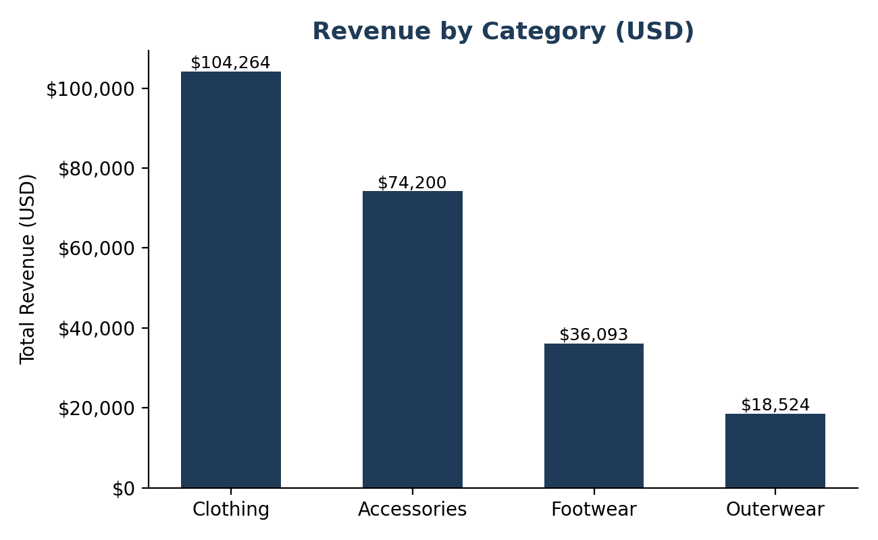
Figure 1. Revenue by Category — mirrors the dashboard's “Revenue by Category” column chart.
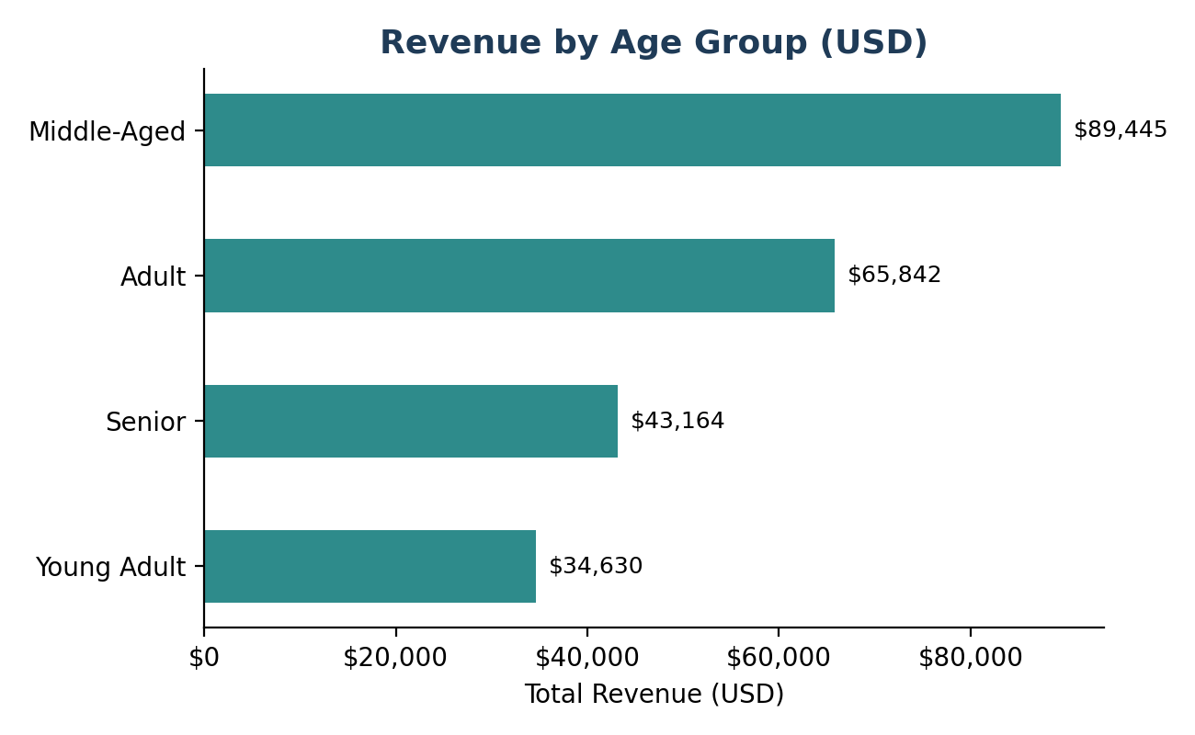
Figure 2. Revenue by Age Group — mirrors the dashboard's “Revenue By Age Group” bar chart.
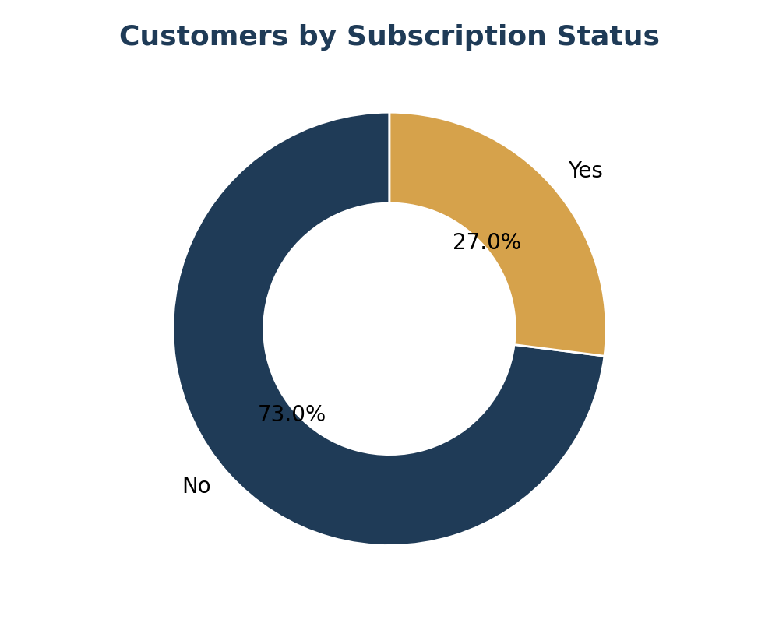
Figure 3. Customers by Subscription Status — mirrors the dashboard's donut chart (72.3% not subscribed, 27.0% subscribed).
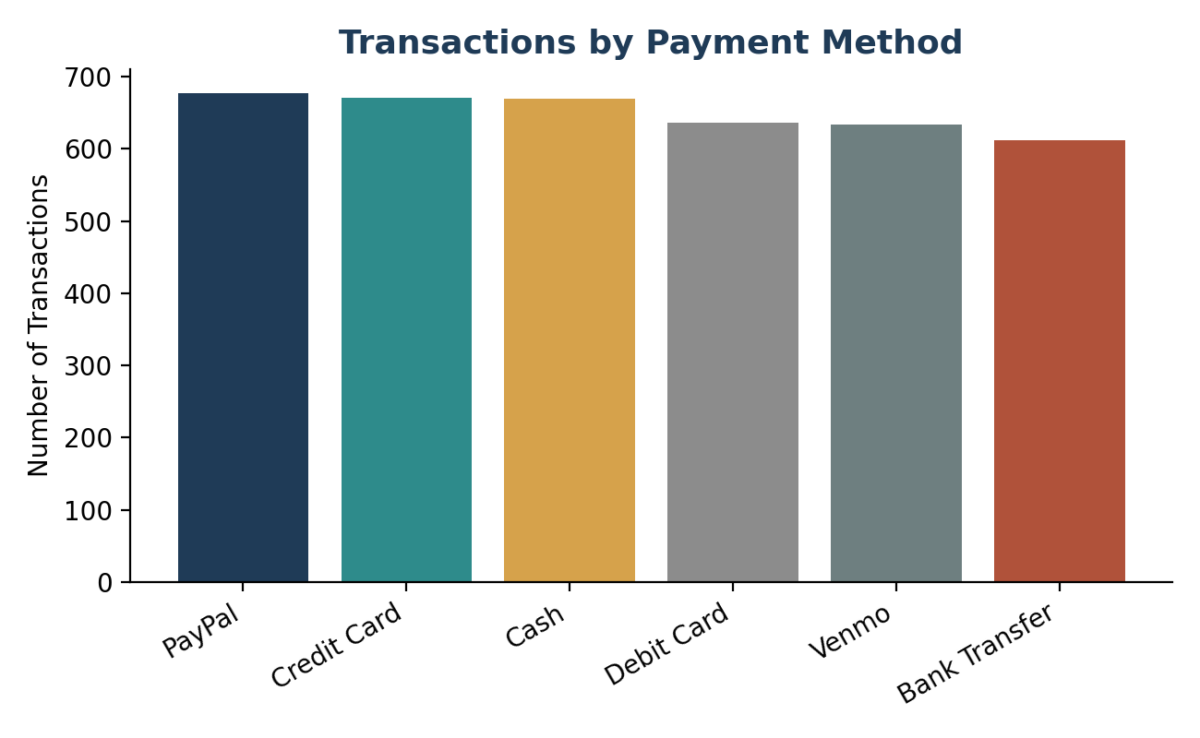
Figure 4. Transactions by Payment Method — supporting detail behind the dashboard's payment-method breakdown.

5. Key Findings
- Spending is uniform, not segment-driven. Average basket size ($57–$61) and satisfaction (3.7–3.8) barely move across age, gender, subscription, or payment method — aggregate revenue differences are explained by segment size, not by any group spending meaningfully more per visit.
- Category concentration. Clothing (44.7%) and Accessories (31.8%) together generate 76.5% of all revenue; Footwear and Outerwear are secondary categories.
- Loyalty runs deep but flat. 39.7% of customers (1,549) have made 30+ previous purchases, showing a large repeat-buyer core — but this group's basket size ($60.03) is no higher than the company average, so loyalty currently shows up as frequency, not bigger baskets.
- Subscriptions and discounts show a soft, not strong, loyalty lift. Subscribers and discount users have modestly higher previous-purchase counts (+1.0 and +0.68 respectively) but not larger baskets — discount users in fact spend $0.85 less per transaction on average.
- Fulfillment experience affects satisfaction. Standard and 2-Day Shipping post the highest ratings (3.82 / 3.77) and repeat-purchase depth, while Store Pickup is the lowest-rated channel (3.71).
- Mild seasonality. Fall is the strongest quarter ($60,018) and Summer the weakest ($55,777), a ~7% swing — not a sharp seasonal cliff, but enough to plan around.
- No payment-channel risk. All six payment methods sit within a narrow 612–677 transaction band, so there is no single point of checkout dependency.
- Geography is dispersed. The top 5 revenue-generating states (Montana, Illinois, California, Idaho, Nevada) are within a tight $200–300 band of each other — no single region dominates.

6. Business Recommendations
- Protect and grow the core categories. Prioritize Clothing and Accessories in merchandising, inventory planning, and campaign spend, since they already carry 76.5% of revenue.
- Shift from demographic to behavioral targeting. Because age, gender, and payment method don't meaningfully predict spend, replace broad demographic offers with targeting based on purchase frequency and previous-purchase count, where the (small) real signal actually lives.
- Convert non-subscribers deliberately. 73% of customers (2,847) are not subscribed. A structured subscription push — even one that only lifts this group's engagement to match current subscribers — would meaningfully grow repeat-visit frequency.
- Audit discount ROI. Since discount users show a slightly lower average basket, test whether current promo codes are driving incremental purchases or simply subsidizing sales that would have happened anyway; consider narrower, time-boxed offers instead of broad, always-on discounts.
- Invest in fulfillment quality. Expand or promote Standard and 2-Day Shipping, and investigate the causes of lower satisfaction in the Store Pickup experience.
- Plan light seasonal campaigns. Use Fall momentum as a template and add modest promotional support in Summer to close the ~7% seasonal gap.
- Build a dedicated retention track for the loyal core. The 1,549 customers with 30+ previous purchases are the company's most durable relationship — prioritize them for loyalty perks, early access, and win-back campaigns to defend this base and look for ways to grow their basket size, not just their visit count.

7. Project Repository & Deliverables
All project artifacts are version-controlled and available in the GitHub repository:
https://github.com/theaditya24/customer-trends-data-analysis-SQL-Python-PowerBI
- Python: Customer Behaviour Analysis.ipynb — data cleaning, missing-value imputation, feature engineering, and SQL loading.
- Data: customer_shopping_behavior.csv — the source dataset (3,900 rows × 18 columns).
- SQL: Segment, loyalty, and purchase-driver queries against the cleaned customers table (Section 3 of this report).
- Power BI: Customer_Behaviour_Dashboard.pbix — the interactive dashboard described in Section 4.
- Report: This document — summarizing findings and recommendations for stakeholders.

